Course Syllabus 2024-2025

Teacher: Ms. Thornton
Email: Thornsh@richmond.k12.ga.us
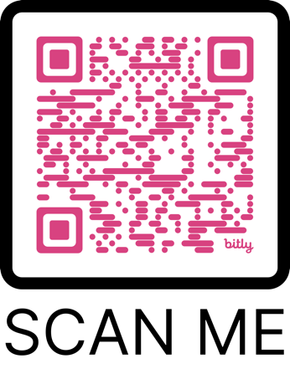
Parent Teacher Conference can be schedule using the QR code.

Math 6
Course Outline
Unit 1: Systems and Operations
Unit 2: ration and Rate Reasoning
Unit 3: Expression, Equations, and Inequalities
Unit 4: Relationships in Geometry
Unit 5: Data Collection and Analysis

Course Expectations
Students in my class are expected to develop independent critical thinking skills, writing skills, collaboration skills, and organizational skills that will be crucial in high school, college, and the outside world.
Students are expected to come to my class prepared and to complete assignments on time.

Missed work.
It is the student’s responsibility to obtain any missed assignments, notes, or other pertinent information necessary due to an absence or tardy. Students must have a verifiable excuse to receive full credit for missed assignments due to an excused absence. ALL missing work must be turned in 5 days after students return. I will not accept late work pass the 5-day mark!!!

Class Procedures
RCSS Code of Conduct and Hornsby Middle School Student Handbook outlines the official progressive discipline policy which may be activated based on the student’s behavior and the judgment of an administrator.

Rules: SOAR-
- I will use self-control over my actions.
- I will remain on task and on time.
- I will demonstrate acceptance of others and their differences.
- I will respect my school, pears, and teachers.
- I will be the best version of myself.

Consequences: Warning, silent lunch, team timeout, parent contact, detention, office referral (some behaviors require immediate office referral included in student Code of Conduct)

Grading Plan
The DISTRICT GRADING PLAN is applied to points earned by the end of a grading period is as follows: A =100-90; B=89-80; C=79-75 D=74-70; F=69 and below.
Assignment grades are recorded on a point basis.
A grade may count more than once depending on the skill(s) assessed. Term grades are calculated as a percentage of the total points possible. Areas evaluated will be weighted as follows:
Major Grades (Tests and Projects) 40%
Minor Grades (Quizzes, Classwork, and Homework) 60%

*Parents may access student grades via the Infinite Campus Parent portal.

Homework
Homework isn’t optional when assigned. It Is the student responsibility to get their homework from the board!!

Supplies:
- Spiral notebook or composition notebook.
- Looseleaf Paper
- Pencil/blue or black pen
- 2 Earbuds/Headphones
- Tissue and Hand Sanitizer
- Personal Calculator **if wanted**
- Highlighters
- Scissors
- Glue Stick
- Ruler
- Color Pencils
- Post it notes

Signature:_____________________________________________________________________

